**Report for the Committee of the Judith Clark Memorial Fellowship:**

**Kate Oswin**

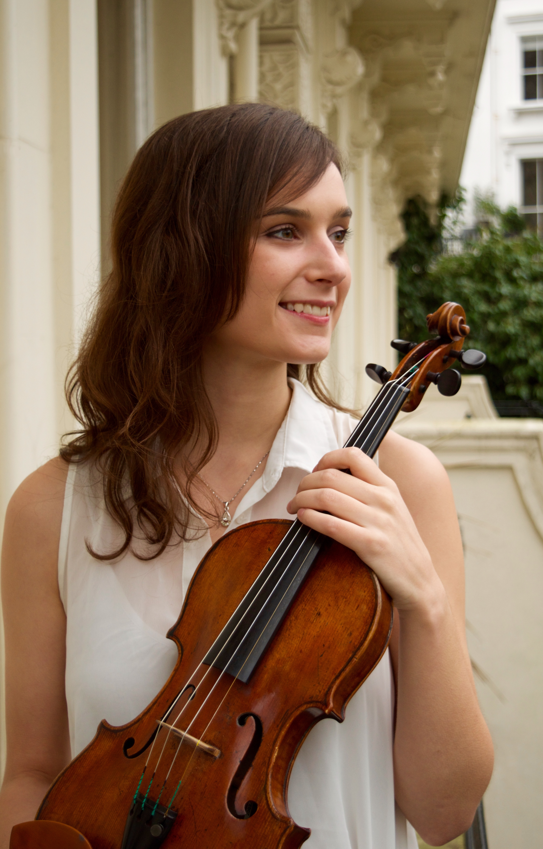In July 2015 I attended the Summer Music Academy Sinaia, a two-week course organised by the European Music Academy. The village of Sinaia is the former summer residence of George Enescu, and is located at the base of the Bucegi Mountains in Romania. The school involved string and flute students from all over the world, most of whom were currently either studying at European conservatoires or recently graduated. Every student received individual masterclasses open to the public, sessions with an accompanist, free entry to all the concerts held in the Summer ‘EuropaFest’ which was held concurrently, as well as a performance in one of the three student Gala concerts held at the end of the festival.

My principal teacher at the course was Remus Azoitei, who is also my main professor at the Royal Academy of Music in London. Remus is an international soloist and chamber musician, who is particularly renowned for his recordings of the complete violin works of George Enescu, and is himself a former student of Itzhak Perlman and Dorothy Delay at the Julliard School. During the course we worked intensively on the Bach Chaconne, in direct comparison to the Chaconne movement of the Bartók Solo Violin Sonata. We also began work preparing the Beethoven Violin Concerto for my exams at the Royal Academy. Another of Remus’ students, who has recently completed her Masters studies, was also studying the Bach Chaconne and the Bartók Solo Sonata at the course, so it was interesting for us to be able to participate in each other’s masterclasses throughout the summer school.

The first three concerts in the Summer ‘EuropaFest’ were given by the professors and other invited artists, and were held at various important historical venues around the village. Remus opened the festival in the Peles Castle with the Bach Chaconne. I had already heard Remus perform the Chaconne at St-Martin-in-the-Fields in London, so it was inspiring to hear it again just as I was about to commence intensive work on the piece. Remus and Luigi Gageos, the Artistic Director of EuropaFest, selected me to close the festival in the Sinaia Catholic Church, where I also performed the Bach Chaconne. It was a beautiful space in which to play, and it was quite an experience to give my first performance of such a monumental work there, especially as I had the additional pressure of being compared so directly to my professor! I was very pleased with how I performed the work, and I was humbled by the audience’s response, which called me back for four bows following my performance.

I would like to sincerely thank the Judith Clark Memorial Fellowship Committee for supporting me in my studies at the Summer Music Academy Sinaia this year. It was an invaluable experience to study in such an inspiring learning environment along with other talented young musicians from around the world!

29 August 2015